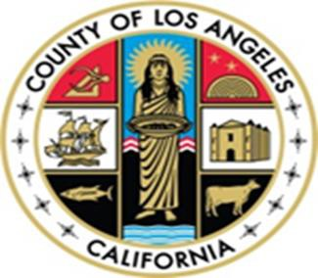

NOTICE

January 1, 2026

The Los Angeles County Behavioral Health Member Handbook has been updated, effective February 1, 2026, and is available in different languages on the Substance Abuse Prevention and Control Patient Resource and Information webpage: https://publichealth.lacounty.gov/sapc/PatientPublic. To obtain a free printed copy, please request through your provider and one will be provided to you within five (5) business days.

Updates to the Member Handbook include sections on Additional Information About Your County, Words to Know, Notice of Privacy Practices, and information about new types of services (as applicable) such as, but not limited to:

- Parent-Child Interaction Therapy (PCIT)
- Functional Family Therapy (FFT)
- Multisystemic Therapy (MST)
- Assertive Community Treatment (ACT)
- Forensic Assertive Community Treatment (FACT)
- Coordinated Specialty Care (CSC) for First Episode Psychosis
- Clubhouse Services
- Enhanced Community Health Worker Services
- Supported Employment
- Traditional Health Care Practices
- In-Reach Services

If you need help in your language, auxiliary aids or services for your disability, or to obtain documents in braille or large print, they are available upon request by calling 1-800-854-7771 (TTY: 711). These services are free.

